Apple is known for being one of the most challenging places to work at, so it's not surprising to learn that getting a job there is no easy task.

Like Google and other big tech companies, Apple asks both technical questions based on your past work experience and some mind-boggling puzzles. We combed through recent posts on Glassdoor to find some of the toughest interview questions candidates have been asked. Some require solving tricky math problems, while others are simple but vague enough to keep you on your toes.

Check out 25 of the toughest questions asked in Apple interviews.

**1.** "If you have 2 eggs and you want to figure out what's the highest floor from which you can drop the egg without breaking it, how would you do it? What's the optimal solution?"

Asked to: Software engineer candidate



© shutterstock

**2.** "Who is your best friend?"

Asked to: Family room specialist candidate

**3.** "Explain to an 8-year-old what a modem/router is and its functions."

Asked to: At-home advisor candidate

**4.** "How many children are born every day?"

Asked to: Global supply manager candidate

**5.** "You have a 100 coins laying flat on a table, each with a head side and a tail side. 10 of them are heads up, 90 are tails up. You can't feel, see or in any other way find out which side is up. Split the coins into two piles such that there are the same number of heads in each pile."

Asked to: Software engineer candidate

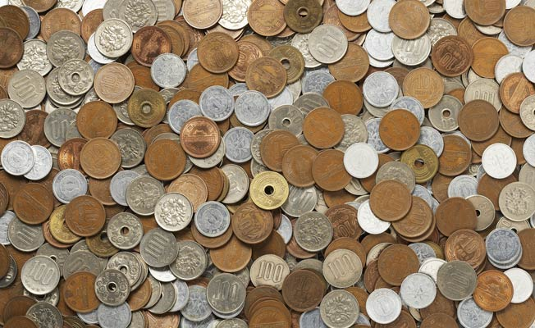

© Thinkstock Photos/Getty Images

**6.** "There are three boxes, one contains only apples, one contains only oranges, and one contains both apples and oranges. The boxes have been incorrectly labelled such that no label identifies the actual contents of the box it labels. Opening just one box and without looking in the box, you take out one piece of fruit. By looking at the fruit, how can you immediately label all of the boxes correctly?"

Asked to: Software QA engineer candidate

**7.** "Scenario: You're dealing with an angry customer who was waiting for help for the past 20 minutes and is causing a commotion. She claims that she'll just walk over to Best Buy or the Microsoft Store to get the computer she wants. Resolve this issue."

Asked to: Specialist candidate

**8.** "How would you breakdown the cost of this pen?"

Asked to: Global supply manager candidate

**9.** "A man calls in and has an older computer that is essentially a brick. What do you do?"

Asked to: Apple Care at-home consultant candidate

**10.** "Are you smart?"

Asked to: Build engineer candidate

**11.** "Have you ever disagreed with a manager's decision, and how did you approach the disagreement? Give a specific example and explain how you rectified this disagreement, what the final outcome was, and how that individual would describe you today."

Asked to: Software engineer candidate

**12.** "You put a glass of water on a record turntable and begin slowly increasing the speed. What happens first -- does the glass slide off, tip over, or does the water splash out?"

Asked to: Mechanical engineer candidate



© shutterstock

**13.** "Tell me something that you have done in your life which you are particularly proud of."

Asked to: Software engineering manager candidate

**14.** "Are you creative? What's something creative that you can think of?"

Asked to: Software engineer candidate

**15.** "Describe a humbling experience."

Asked to: Apple retail specialist candidate

**16.** "What's more important, fixing the customer's problem or creating a good customer experience?"

Asked to: Apple at-home advisor candidate

**17.** "Why did Apple change its name from Apple Computers Incorporated to Apple Inc?"

Asked to: Specialist candidate



© Reuters

**18.** "You seem pretty positive, what types of things bring you down?"

Asked to: Family room specialist candidate

**19.** "Show me (role play) how you would show a customer you're willing to help them by only using your voice."

Asked to: College at-home advisor candidate

Tough Questions Asked In Apple Interviews "Given an iTunes type of app that pulls down lots of images that get stale over time, what strategy would you use to flush disused images over time?"

Asked to: Software engineer candidate

**21.** "If you're given a jar with a mix of fair and unfair coins, and you pull one out and flip it 3 times, and get the specific sequence heads heads tails, what are the chances that you pulled out a fair or an unfair coin?"

Asked to: Lead analyst candidate

**22.** "What was your best day in the last 4 years? What was your worst?"

Asked to: Engineering project manager candidate

**23.** "Why do you want to join Apple and what will you miss at your current work if Apple hired you?"

Asked to: Software engineer candidate

**24.** "How would you test your favourite app?"

Asked to: Software QA Engineer candidate

**25.** "How would you test a toaster?"

Asked to: Software QA engineer candidate

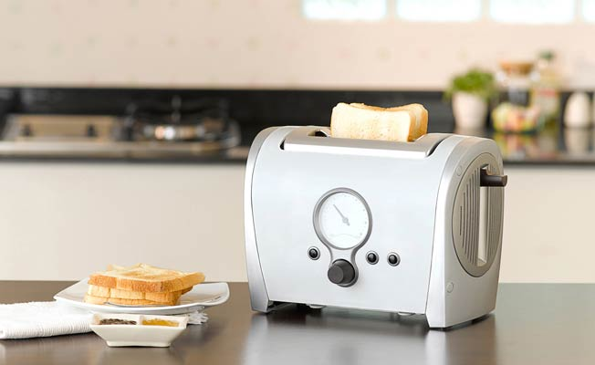

© Thinkstock Photos/Getty Images

(This story appeared in The Times Of India)

Photo: © Reuters (Main Image)